**ASSESSMENT - DBMS**

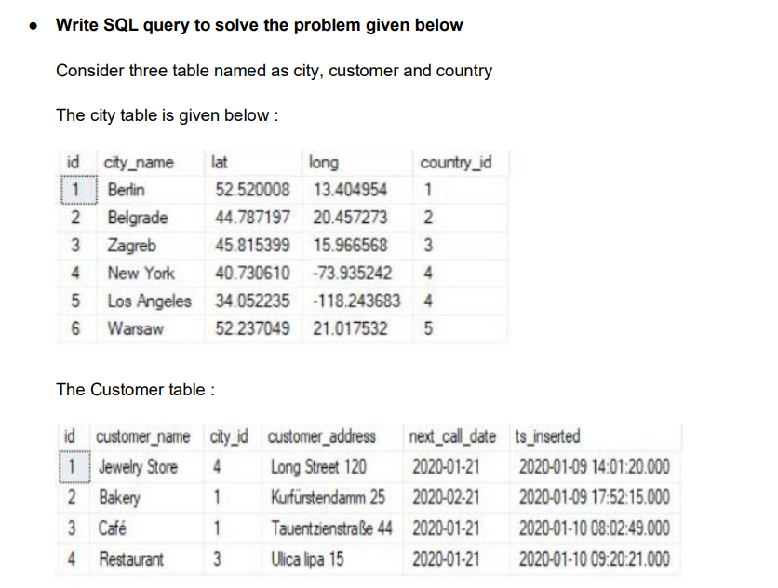

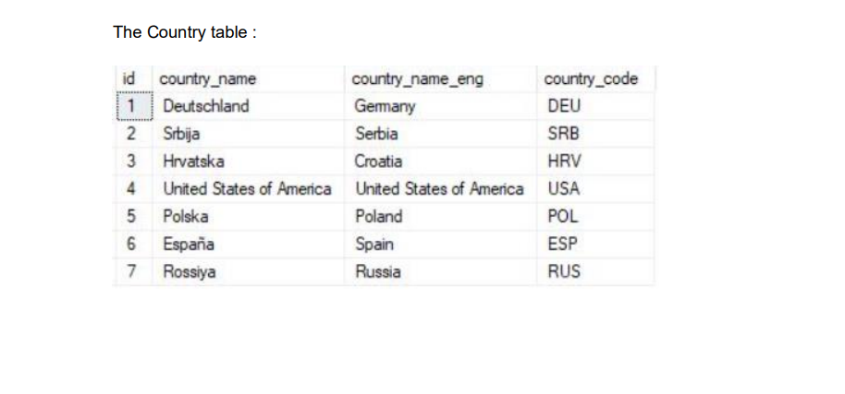

* While each city has a related country, not all countries have related cities (Spain & Russia don’t have them)
* Same stands for the customers. Each customer has the city_id value defined, but only 3 cities are being used (Berlin, Zagreb & New York)

Now commute the following tasks:

Task: (Join multiple tables using left join)

List all Countries and customers related to these countries.

For each country displaying its name in English, the name of the city customer is located in as well as the name of the customer.

Return even countries without related cities and customers.

**SOLUTION 🡪**

**Table 1-**

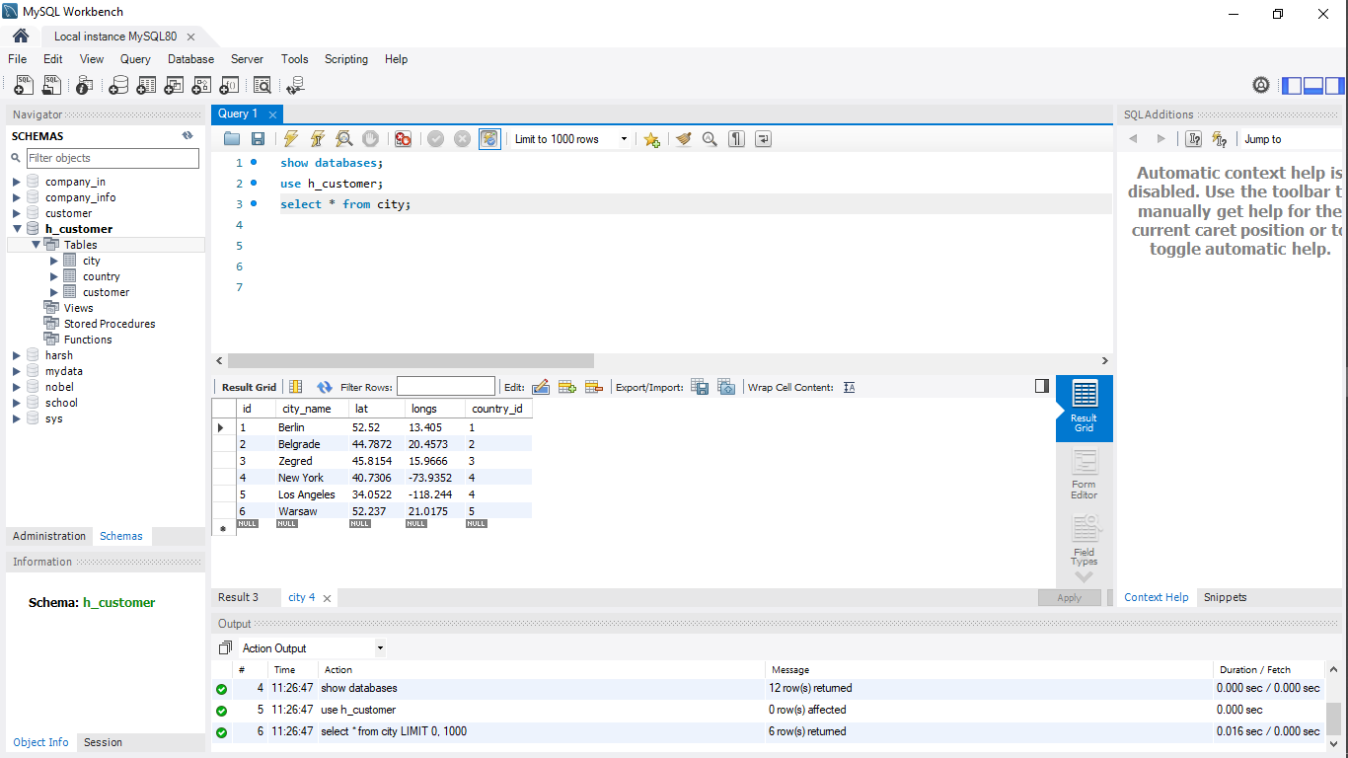

**Table2-**

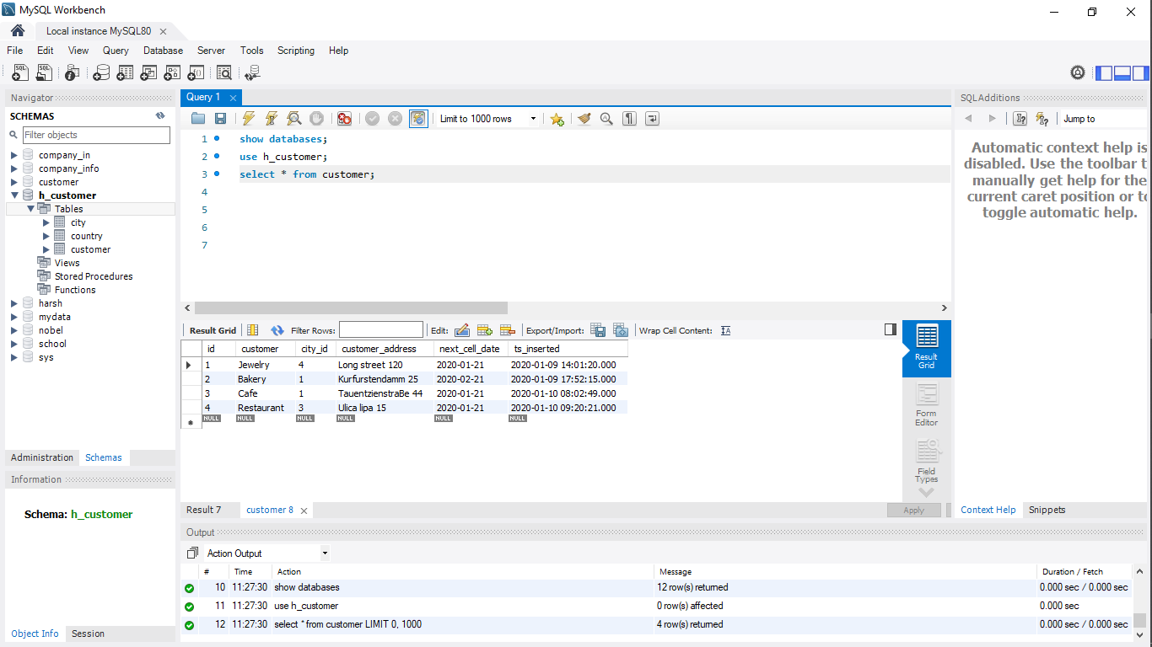

**Table3-**

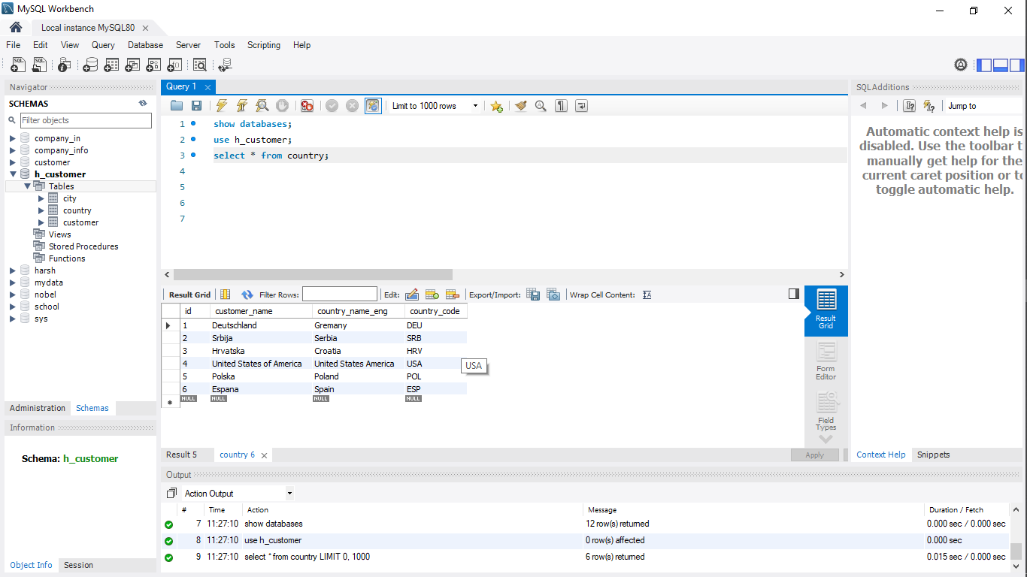

List all City and customers related to these countries 🡪

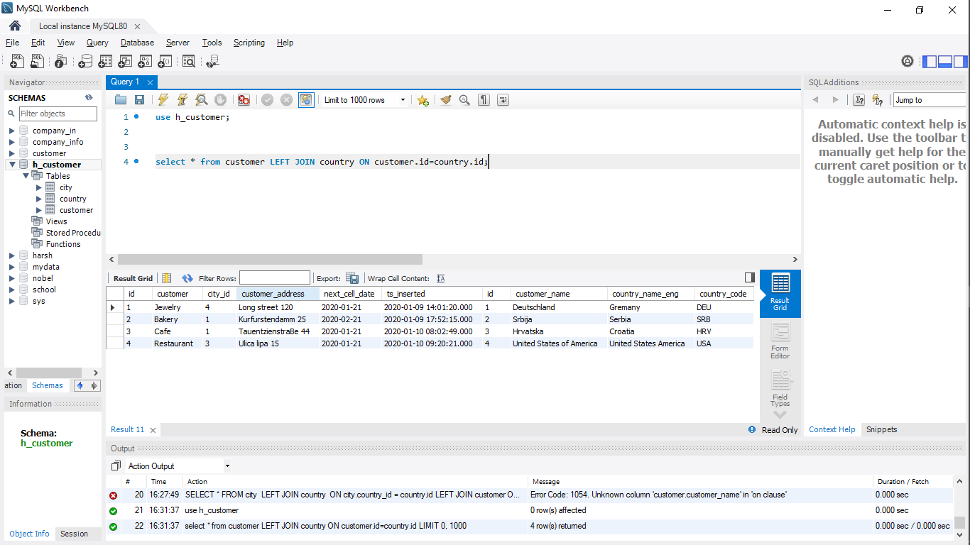

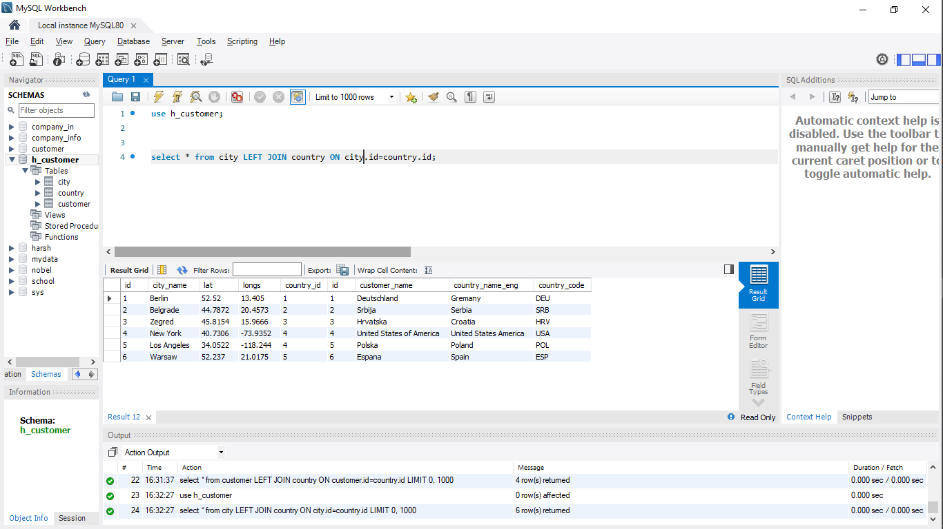

Each country displaying its name in English, the name of the city customer is located in as well as the name of the customer 🡪

